TIPS TO BUILD YOUR SOCIAL MEDIA PRESENCE & OURS
And Have Fun in the Process!
April 2018

WHY ENGAGE IN e360tv SOCIAL MEDIA
- Generate Personal and Company Brand Awareness through Regular Activity
- Drive People to Your Shows, e360tv, & Others through Calls-To-Action (CTAs)
- Build & Maintain Fans/Followers/Customers by Engaging with them
- Capture & Maintain Interest of Current &/or Potential Followers by Publicizing Content
- Create & Reinforce Image of e360tv as a Popular & Trendy Alternative to Mainstream TV
- Co-create the Brand with Other Followers
- Monitor and Respond to Online Discussions about Your Show, e360tv, & Others

TIPS FOR POSTING
- Cross-Post (share content across multiple social media channels)
- Repeat Posts
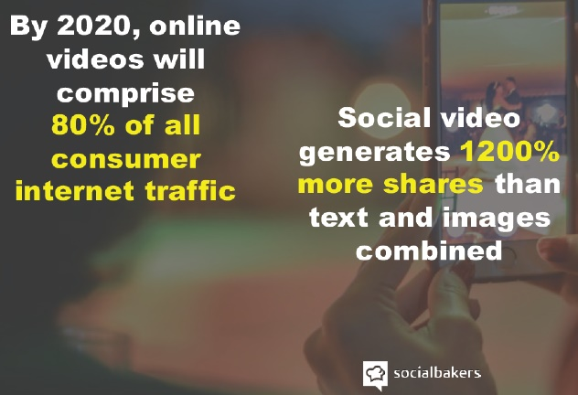
- Use Posts with Images or Video
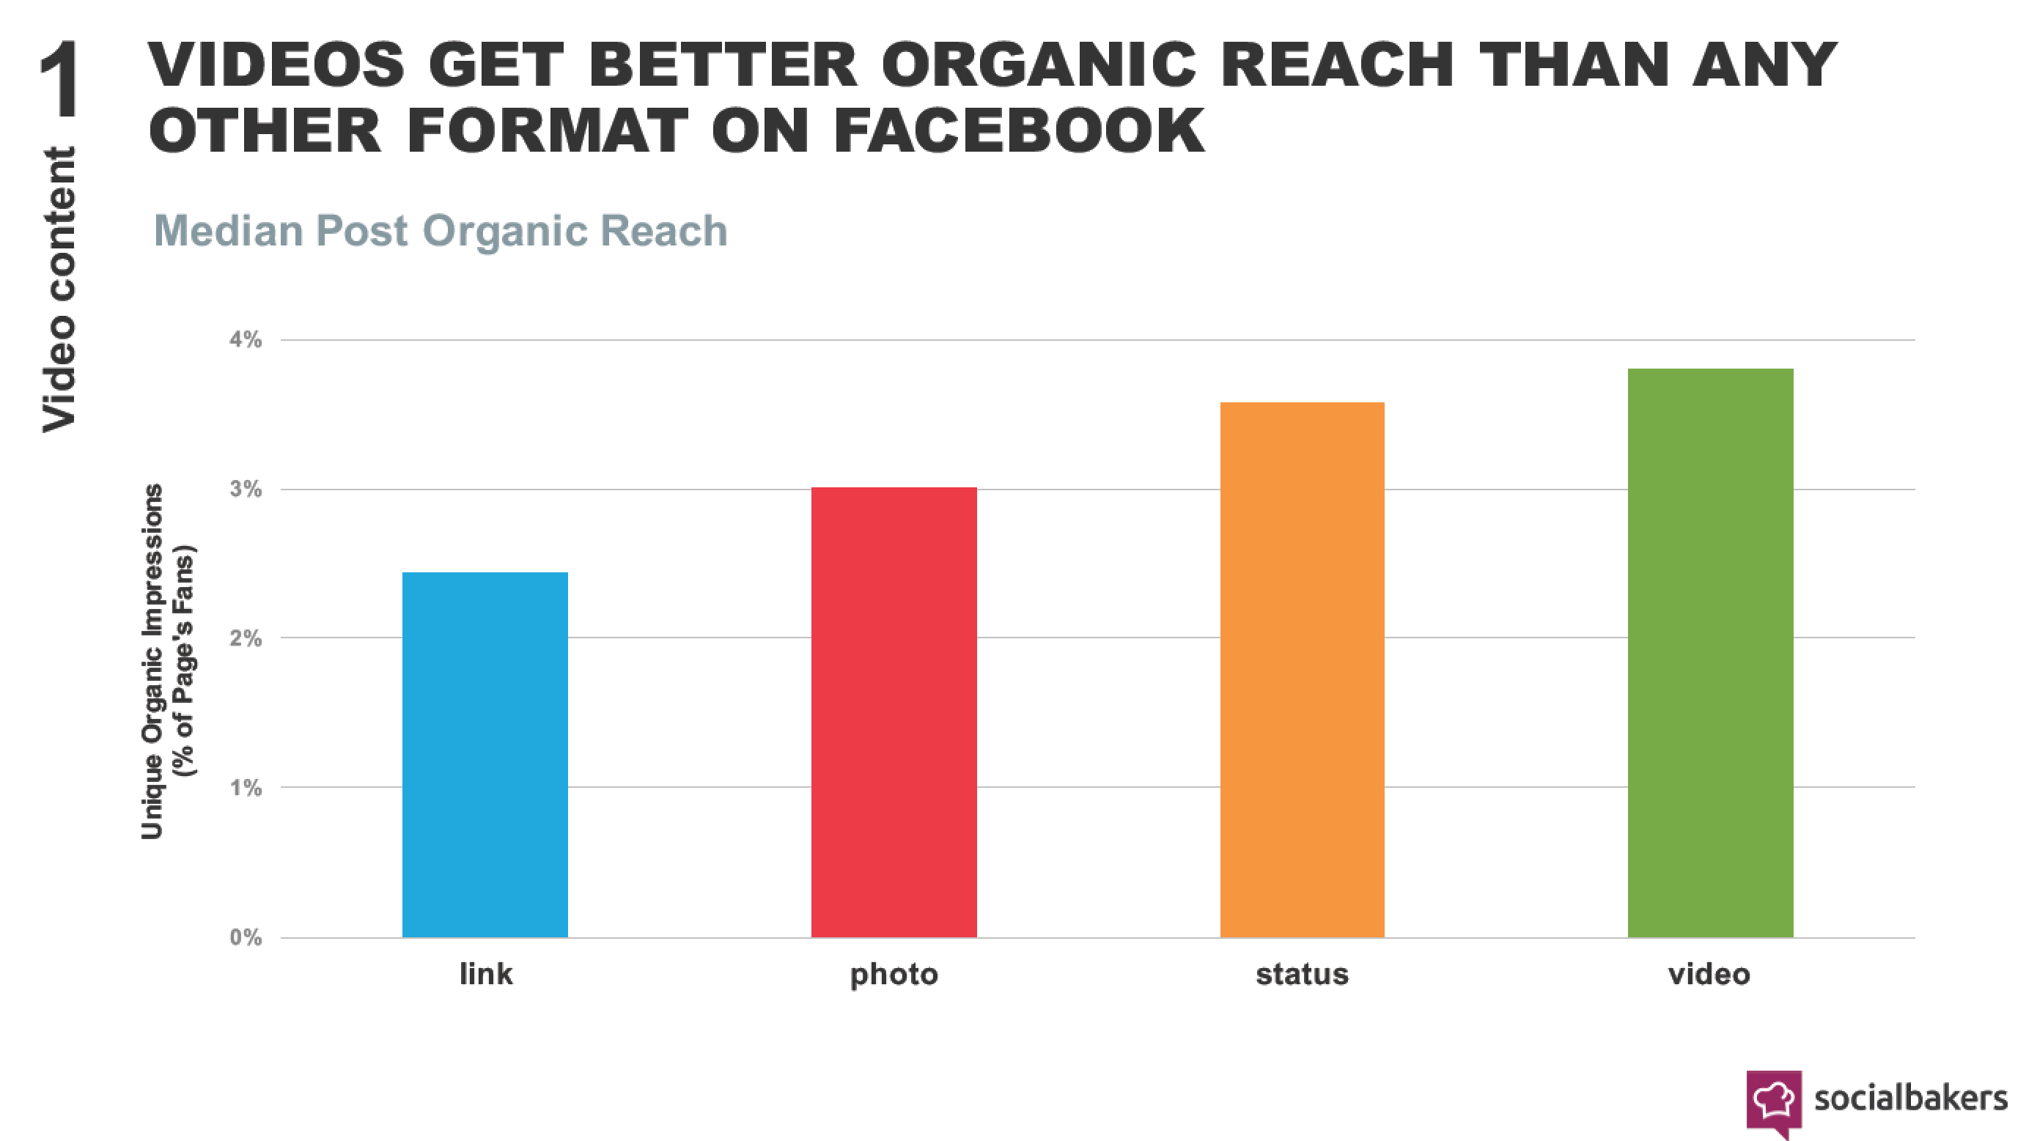

- Post Video Natively (i.e., directly to platform such as Facebook, rather than linking to YouTube or other)
- Use Calls-to-Action (CTA) – to drive traffic to e360tv.com and engage others
- Engage with Others
  - Be authentic and Genuine. Social media users like real people.
  - Ask a Question on Your Post to Solicit Responses from Others
  - Comment on Posts
  - Share Posts (e360tv and others) & Credit Posters
  - Tag People on Posts (i.e., Twitter, LinkedIn, Facebook, Instagram)
  - Follow e360tv on all Social Media Platforms Where You Have an Account
  - Follow Those Who Follow You
- Use Hashtags for SEO and for uses who search by hashtags / topics [Sources: Rite Tag, Twitonomy, Hashtagify.me, & others] Tag #e360tv whenever possible.

e360tv / Canna Media Network-Specific (for branding and driving traffic)

#e360tv
#CMN
#cannamedianetwork
#abovethesmoke
#healthyliving
#cannisworld
#freshtake
#extremesports
#culture
#entertainment
#OTT

Popular on Twitter (Good for posts across channels- i.e., living, trending culture)

#cannabis
#lifestyle
#fitness
#love
#health
#cooking
#food
#media
#socialmedia
#tech
#bigdata
#fintech
#trending
#news
#entertainment
#music
#culture
#video (good for skateboarding; skateboarding gets little traction)

Popular on Instagram

#love
#photooftheday
#fashion
#happy
#followme
#picoftheday
#follow
#report
#fun
#style
#fitness
#follow4follow
#amazing
#bestoftheday
#healthy
#lifestyle
#inspiration
#followback
#throwback
#weekend
#tattoo
#awesome
#artist
#dinner
#relax
#health
#goodtimes

Cannabis Specific

#Cannisworld
#chronic
#oil,
#hemp
#concentrate
#cannabiscommunity
#weedstagram
#weedstagram420
#weedmapsmadness
#waxcoast
#vibesphere
#twaxgang
#topshelflife
#stonedbynature
#medicinal

Pinterest: No hashtags needed. Pinterest searches for related items whether you tag
them or not. For e if you search for #socialmedia,' you'll get results for
'#socialmedia', 'socialmedia' and 'social media.”

Facebook: No hashtags needed. Unlike Twitter, a largely open network where all tweets
are added to a global conversation, Fb targets more private and targets discussions
immediate connections & networks. [Buffer & BuzzSumo analyzed >1b posts from >30m
brand Pages) & found: “…posts without a hashtag fare better than those with one.”
Socialbakers: hashtag use leads to significantly less engagement on Fb. Exception:
specific events or promotions used with other media.”]

Google+: Use ripples on posts to see who is sharing your content.

- Use Tags to Notify Others You Have Mentioned them in Posts and to Engage Others in Conversation
  - Tag via Facebook, Instagram, other usernames (@CindyAshton @MelissaHull @KTOC @Fourrestfilms @e360tv @360Studios)
  - Test username by typing @ and name of person you or group you want to reference in the search field

Facebook Post Example:

Season 2 of #CindyUncorked on e360tv kicks off today! In celebration, special guest, @ dana pharant and I tackle "Has the #MeToo movement gone too far?"
Join us for this important discussion & have your opportunity to #GetUncorked!
If you love this topic, then be sure to also check out episode 1 where Dana and I #GetUncorked about the ugly truth about the #self-help world – on Roku, Apple TV, Amazon Fire and more. Download the app for free "e360tv" or watch on www.e360tv.com

@e360tv @cindyuncorked #psychology

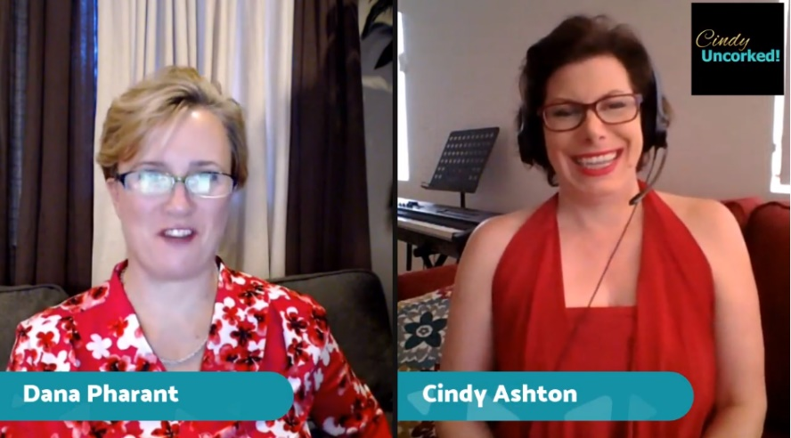

[Video]

WHAT TO POST
Here are some sample Facebook posts to get you started (possible twitter & Instagram hashtags are listed to the right of images).
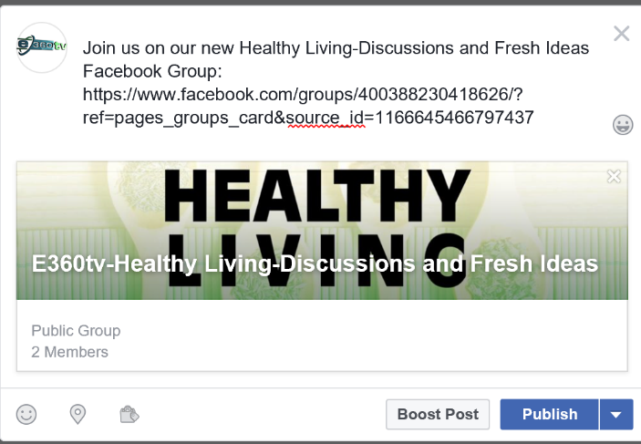
As a show host, you would change “join us” to “join me” or “join me and other Healthy Living show hosts…”
Twitter: #health #healthy #e360tv
Instagram: #healthy #lifestyle #e360tv
If cross-posting, us all hastags.

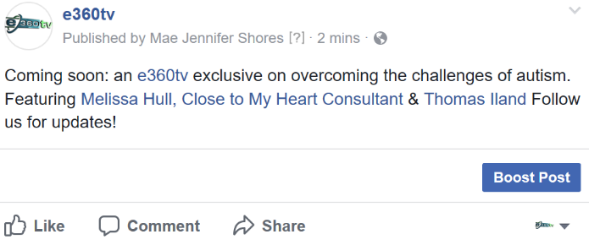
Twitter: #e360tv #autism

Instagram: #e360tv #autism #followback

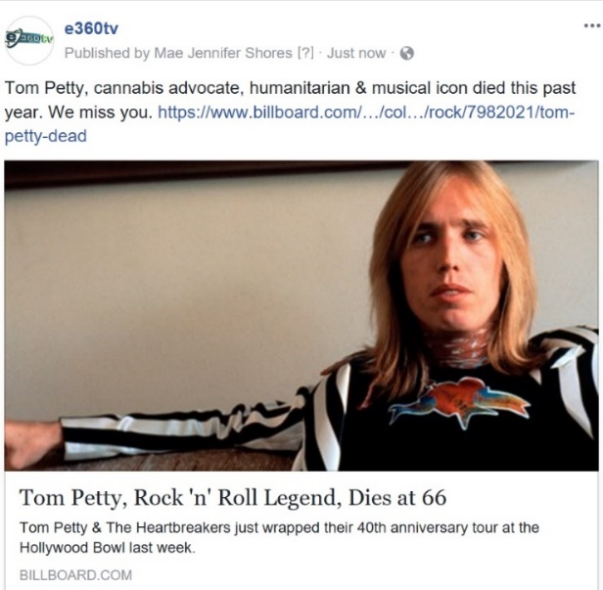

Twitter: #TomPetty #Petty #entertainment #media #e360tv @e360tv
Instagram: #photooftheday #pelotherapy #artist #Thompsett #e360tv @e360tv

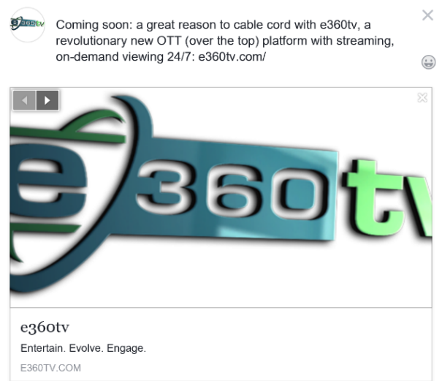
Twitter: #360tv #OTT #media #entertainment
Instagram: #e360tv #OTT #media #entertainment

Looking for a fresh take on news events? If so, join me and other notables on e360tv’s Fresh take channel: e360tv.com/fresh-take/
Are you one of the “tribe” of mainstream consumers interested in emerging progressive, alternative communities? If so, join me on e360tv’s on-demand programming: e360tv.com
WHERE TO POST
e360tv has a presence on the following social media channels. All are valuable to developing your brand, our brand, and generating engagement.

Social Media Sites
- Facebook home page
- Facebook Group pages
  - Healthy Living
  - Culture
  - Entertainment
  - Fresh Take
  - Extreme Sports
  - CannisWorld
- Twitter
- Pinterest
- Instagram
- Google+
- LinkedIb

Two of the larger platforms, where a great many of our current and potential audience members are active, are Facebook and Instagram. Of the two, Facebook receives the greatest traction for media and community. Instagram is great for celebrities and building brands.

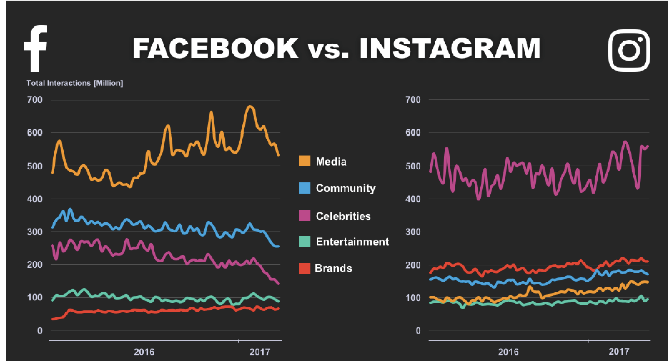

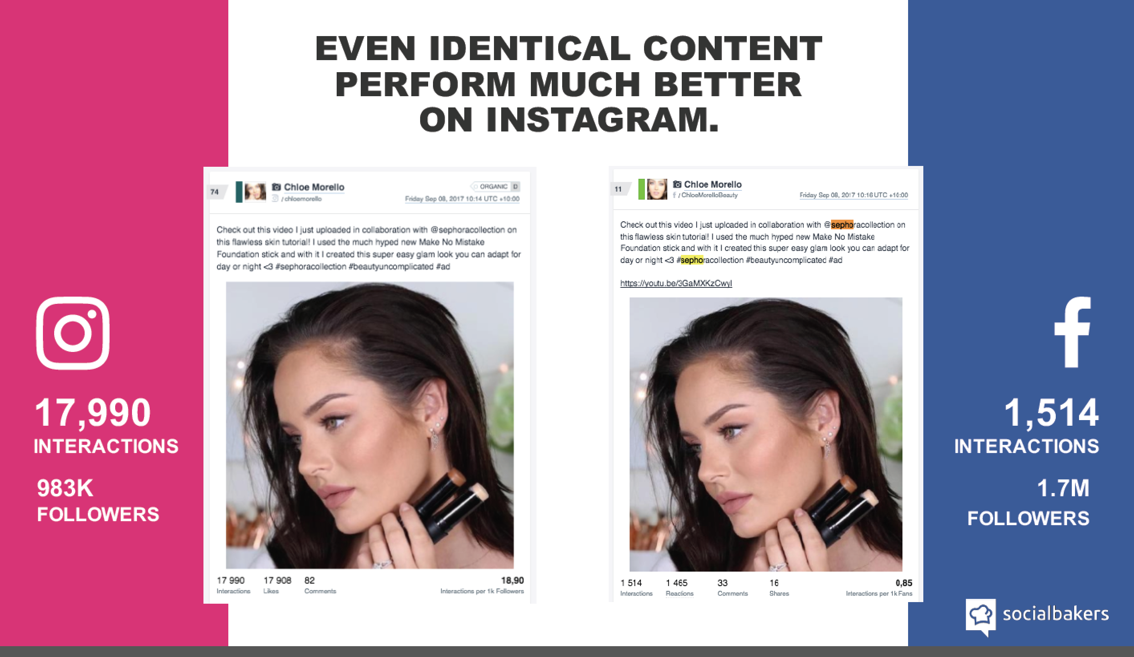

CODE OF ETHICS: Dare we say it? There is a growing body of norms of behavior that social media participants need to respect. Here are commonly accepted guidelines:

- Tell the truth. Words and images create powerful messages that should be used with care. When posting content, present the facts as they are, even if you disagree with them.
- Consider the Source. The sources we quote, link to, or reference reflect our brand. E360tv and Canna Media Network (CMN) are dedicated to offering credible, reputable entertainment and media in a young, emerging market with many companies with questionable or tainted credibility. Remember: we want to remain “above the smoke.”
- Credit sources. If you post or borrow content from another source, attribute the source through a quote, link to original articles, posting the name(s) of creators of photos or illustration, etc.
- Separate Opinion from Fact. Acknowledge what you post as opinion, interpretation or conjecture rather than as fact. If you post something related to e360tv, which reflects your own opinion and not necessarily that of e60tv, use a disclaimer to the effect, “views expressed are mine and don’t necessarily reflect those of e360tv”.
- Respect Opposing Views. The beauty of open dialogue in a democracy that individuals can express differing opinions. It’s okay to agree to disagree.
- Admit and Correct Mistakes Immediately. If you inadvertently post something inaccurate, correct it immediately and announce that you have done so.

For more information, view the social media policies of different companies and organizations in this Hootsuite post. And, of course, feel free to reach out to us with any questions you have.

WHEN TO POST
Research from more than 20 studies reveals the best times to post for maximize exposure.

PLATFORM | POSTS/DAY | BEST TIMES TO POST | ALT GOOD TIMES
Facebook | 2 max | Th & Fr: 1-4pm; We: 3pm | 1pm, 3pm, 9am
Twitter | 3+ | We: 12pm, 5-6pm; M-F, 12-3pm, 5pm; Experiment: 2-3am, 6-7am, 9-10pm | 5-6pm, 12pm, 3pm
Pinterest | 5+ | Sa: 8-11pm (9pm peak), Fr: 3pm | 2-4am, 2-4pm, 1-3pm
Instagram | 1.5+ | M & Th: all times but 3-4pm; video: Mo-Sa, 9pm-8am; experiment: 2am, 5pm, We 7pm | 8-9am, 2am, 5pm
Google+ | 3 max | We: 9am, M-F: 9-11am | 9am, 11am, 12-1pm
LinkedIn | 1 | Tu:10-11am; Tu-Th: 7:30-8:30am, 12pm, 5-6pm | ↑ clickthrus: 5-6pm, 7-8am, 12pm

A FINAL NOTE
Social Media is Changing all the Time! Be Sure to Experiment and Try New Things. As Guy Kawasaki aptly put it: “That’s Where the Social Media Magic Happens.” Let’s Create Magic Together and Share With One Another What we Learn.

